(Approx. 582 words)

Linux and Open Source News
Calibre, featured Open Source Software of the Month - October 2014
By Geof Goodrum, Director, Linux Support, Potomac Area Technology and Computer Society, Virginia
October 2014 issue, PATACS Post
www.patacs.org
linux (at) patacs.org

The software described below can be downloaded at the links provided. However, please check the online package management tool included with your GNU/Linux distribution first, as installation is often just a click away.

Calibre – v2.0.0. http://calibre -ebook.com/
Free GNU General Public License source code and executable packages for Microsoft® Windows®, Apple® OS X® and GNU/Linux® by Kovid Goyal et al. Calibre is a free and open source e-book library management application developed by users of e-books for users of e-books. Features include eBook library management, eBook format conversion, syncing to eBook reader devices, downloading news from the web and converting to eBook format, comprehensive eBook viewer, server for online access to your eBook library, and an editor to create eBooks in major formats (including EPUB and Kindle AZW3). This major release features bug fixes by upgrading Qt 4 to Qt 5, and adds support for MTP devices (e.g., Android) on OSX.

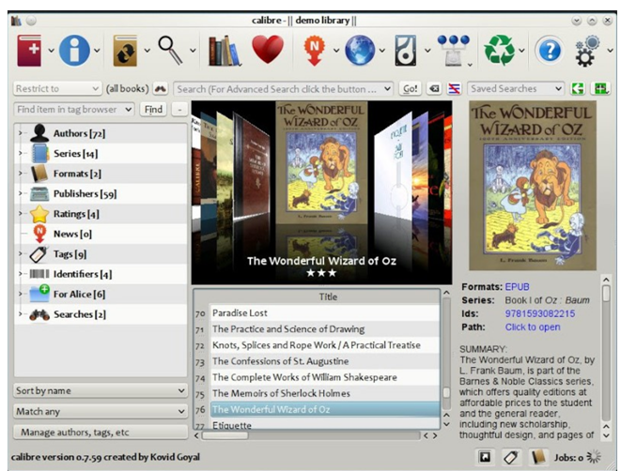

Data Crow – v4.0.7. http://www.datacrow.net/. Free GNU General Public License Java source code and executable for Microsoft® Windows®, Apple® OS X® and GNU/Linux® by Robert Jan van der Waals. Data Crow Data Crow is the ultimate media cataloger and media organizer, with standard modules for movie and video, book, images, games and software, and music cataloging. You can modify these modules or create new modules (want to catalog your stamps, equipment, or anything else?). Data Crow provides information on your items through online services such as Amazon, Internet Movie Database, Sourceforge.net, Softpedia, Ofdb, MusicBrainz and many others. Data Crow featured include reporting, loan administration, item importing & exporting, backup & restore, and web services. Requires Java 1.7 or later.
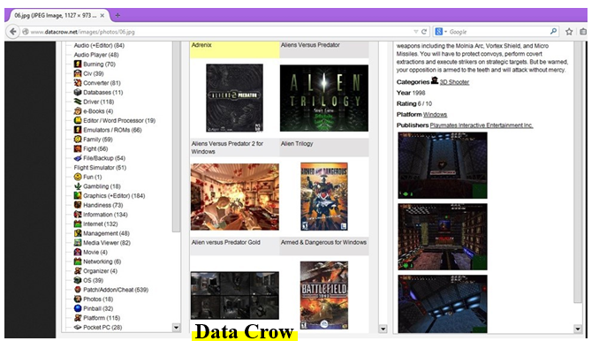

Rubedo – v2.2. http://www.rubedo-project.or g/. Free GNU General Public License source code and pre-built packages for Microsoft® Windows® and GNU/Linux® by WebTales and the Rubedo Community. Rubedo is a scalable, flexible Rubedo Community. Rubedo is a scalable, flexible website content management system (CMS) for online publishing, media management, and E-commerce, and winner of the 2014 CMS- day Front office innovation award. Features include multi-site management, multi-language support, web page and layout editing, adaptive rendering to devices (desktop, tablet, smartphone), design themes, search engine, maps with place search and user geolocation, social network integration, e-mail and newsletter support, Google Analytics to devices (desktop, tablet, smartphone), design themes, search engine, maps with place search and user geolocation, social net- work integration, e-mail and newsletter support, Google Analytics integration for statistics, accessibility, behavioral targeting, and E-commerce. Rubedo is built upon open source Apache web server, MongoDB, PHP, and ElasticSearch.

VASSAL – v3.2.13. http://www.vassalengine.org/. Free GNU Lesser General Public License Source code and executable packages for Microsoft® Windows®, Apple® OS X® and GNU/Linux® by Rodney Kinney and Joel Uckelman. VASSAL is a game engine for creating electronic versions of traditional board and card games. It provides support for game piece rendering and interaction, and supports single player and multiplayer by e-mail or over a live Internet connection. Over one thousand VASSAL game modules are available for download from the VASSAL website covering a wide variety of topics, including card games, and science fiction, fantasy, horror, historical and political games.

NOTE: Some games are conversions of commercial games and require the original game to play.

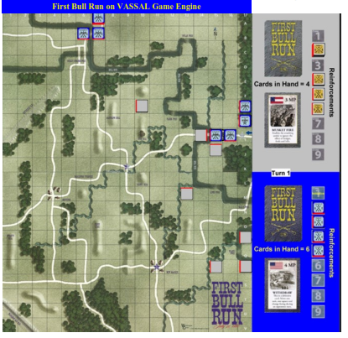

Kernel Source – v3.16.1. http://www.kernel.org/. Free GNU General Public License source code for all platforms by the Linux community

